**Justification Letter**

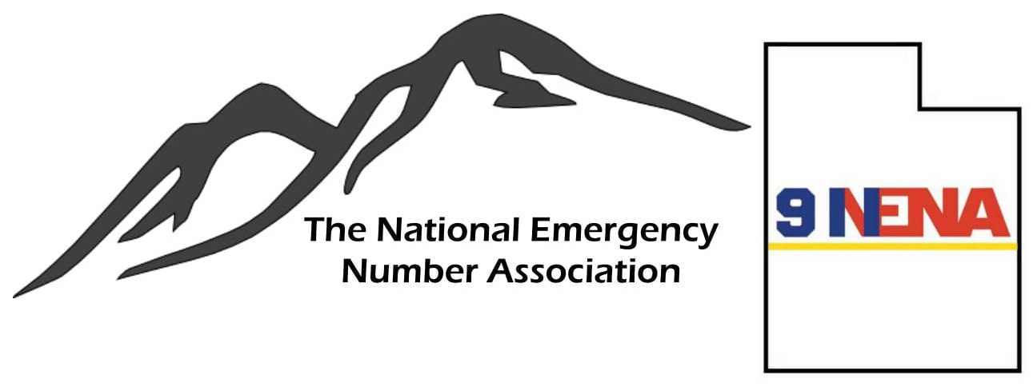We are so excited that you are interested in attending the 2022 NENA Annual Conference and Expo in Louisville, Kentucky. This conference is something every public safety communications professional should experience at least once in their career. There are so many opportunities to learn critical career building skills from amazing instructors, discover new innovative products from hundreds of vendors and network with peers from across the entire country!

If you need help gaining approval from your agency to attend this event, we have prepared a sample letter you can use as a guide. This will help summarize the value that attending the event will provide you and subsequently, your entire organization.

**Subject: Request to Attend the 2022 NENA Annual Conference**

Dear ***(Supervisor)***,

The 2022 National Emergency Number Association Annual Conference is being held June 11-16 in Louisville, Kentucky. The event offers insight on the public safety issues of today and tomorrow, educational training packed with practical, real-world know-how that can be brought back home and put into action immediately. These conferences feature inspiring keynote speakers, dozens of breakout sessions that inform and empower, career-building courses and workshops with real-world applications. Not to mention the nightly networking events to help professionals make the right connections, and an Expo Hall showcasing cutting-edge products and services.

This Conference connects attendees to the pulse of 9-1-1, bringing together thousands of public safety professionals, telecommunicators, and federal, state, and local policymakers for a week filled with chances to develop a keen understanding of the near and long-term issues facing public safety and the skill-sets necessary to tackle these challenges head on. NENA promises to deliver the education, resources, and contacts you need to be better equipped to do your job and actively prepare for the road ahead, no matter what your role is in public safety.

I believe that everything I would gain within the promises of NENA will enhance my ability to provide for the safety and security of our community by gaining a better understanding of best practices presented in the many courses offered as well as keynote sessions and networking events.

When I return from the event, I will prepare a presentation for my peers, outlining speakers, product information, course notes, new ideas and other items that could help benefit our department and its employees. I will also make sure that the training(s) and information I compile are available to my co-workers.

This event costs approximately $700 for registration, however, I have applied for a scholarship that would cover the cost of registratio. In the event that I am awarded the scholarship from our Utah Chapter of NENA, I would like to ask that the department support my attendance in covering all remaining costs not covered by this scholarship.

Thank you for your consideration,

***(Signature)***